**Project Name: Hotel Booking Data Visualization**

**Objective:**

The objective of this project was to analyze and visualize hotel booking data to gain insights into key performance indicators (KPIs) related to cancellations, bookings, and revenue.

**KPIs:**

Cancellation Rate: The cancellation rate was found to be 62%. This KPI measures the percentage of bookings that were canceled out of the total number of bookings.

Booking Conversion Rate: The booking conversion rate was calculated to be 37.06%. This KPI measures the percentage of bookings that were not canceled out of the total number of bookings.

Total Bookings: The total number of bookings recorded was 119,000.

Revenue: The total revenue generated from hotel bookings was $42.72 million.

Average Daily Rate (ADR): The average daily rate was calculated to be $101.83.

**Visualizations:**

Please click [here](https://app.powerbi.com/groups/me/reports/87805ecd-6606-473c-a4c1-8a6a902b6815/ReportSection47fb8a4aeb95427a3b52?experience=power-bi) to access the Power BI report for a visual representation of the analyzed data.

Cancellation by Month:

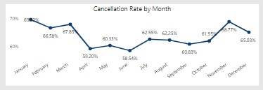

* January had the highest cancellation rate of 69.52%.
* November had the second-highest cancellation rate at 68.77%.
* June had the lowest cancellation rate of 58.54%.

Cancellation by Market Segment:

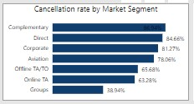

* The "Complementary" market segment had the highest cancellation rate of 86.94%.
* The "Groups" market segment had the lowest cancellation rate of 38.94%.

Cancellation by Distribution Channel:

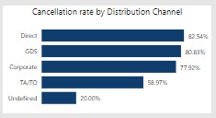

* The "Direct" distribution channel had the highest cancellation rate of 82.54%.
* The "Undefined" distribution channel had the lowest cancellation rate of 20%.

Revenue by Month:

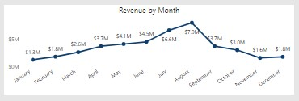

* August generated the highest revenue of $7,944,717.43.
* July had the second-highest revenue of $6,587,713.64.
* November had the second-lowest revenue of $1,600,156.54.
* January had the lowest revenue of $1,273,077.43.

Revenue by Market Segment:

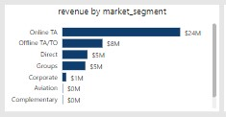

* The "Online TA" market segment generated the highest revenue of $23,942,047.53.
* The "Complementary" market segment had the lowest revenue of $5,082.52.

Revenue by Distribution Channel (Bar Chart):

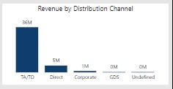

* The "TA/TO" distribution channel generated the highest revenue of $36,096,134.85.

Bookings by Month:

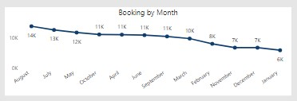

* August had the highest number of bookings with a total of 13,877.
* January had a total of 5,929 bookings, the lowest among all months.
* June had a total of 10,939 bookings and a cancellation rate of 58.54%, indicating a lower booking conversion rate.

Bookings by Market Segment:

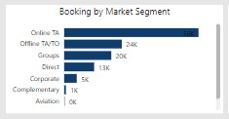

* The "Online TA" market segment had the highest number of bookings with a total of 56,477.
* The "Aviation" market segment had the lowest number of bookings with a total of 237.

Bookings by Distribution Channel:

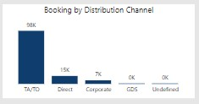

* The "TA/TO" distribution channel had the highest number of bookings with a total of 97,870.

**Insights:**

Cancellation Rate: The cancellation rate of 62% indicates a significant number of booking cancellations. This could be due to various factors such as changing travel plans, dissatisfaction with the booking process, or lack of clear cancellation policies.

Booking Conversion Rate: The booking conversion rate of 37.06% suggests that there is room for improvement in converting potential customers into confirmed bookings. Analyzing the factors influencing this rate can help identify areas for optimization.

Revenue: The total revenue of $42.72 million indicates a substantial business volume. However, further analysis of revenue sources, such as market segments and distribution channels, can provide insights into revenue drivers and opportunities for growth.

Average Daily Rate (ADR): The average daily rate of $101.83 implies the pricing strategy in place. Comparing this rate with competitors and market benchmarks can help assess the hotel's positioning in terms of pricing.

**Recommendations:**

Understand Cancellation Reasons: Investigate the reasons behind the high cancellation rate. Analyze customer feedback and survey data to identify pain points and address them. Improving transparency in cancellation policies and offering flexible options could reduce cancellations.

Improve Booking Conversion: Analyze the booking process and customer journey to identify potential bottlenecks or obstacles. Simplify the booking process, provide clear and persuasive information, and enhance the user experience to improve the booking conversion rate.

Target High-Performing Market Segments: Focus on market segments that have shown high revenue generation, such as the "Online TA" segment. Allocate marketing resources and tailor promotional campaigns to attract and retain customers from these segments.

Optimize Distribution Channels: Analyze the performance of distribution channels and allocate resources accordingly. Consider partnerships and collaborations with high-performing channels, while also exploring opportunities to improve direct bookings through targeted marketing campaigns and loyalty programs.

Revenue Management Strategies: Implement revenue management techniques to optimize pricing and maximize revenue. Conduct regular market and competitor analysis to adjust the Average Daily Rate (ADR) to stay competitive while maximizing profitability.

Enhance Customer Experience: Continuously work on improving the overall customer experience. Monitor and respond to customer feedback, personalize services, and offer value-added amenities or packages to drive customer satisfaction and loyalty.

Seasonal Demand Planning: Analyze the revenue by month and identify peak seasons or periods of high demand. Use this information to plan staffing, inventory, and pricing strategies accordingly, optimizing revenue during high-demand periods and targeting promotions during low-demand periods.

Monitor Market Trends: Stay updated on industry trends, market dynamics, and competitors' strategies. Regularly analyze market data, customer preferences, and emerging trends to adapt and innovate your offerings to meet changing customer demands.